
SIMATS ENGINEERING
Saveetha Institute of Medical and Technical Sciences
Chennai - 602105
IMPLEMENTATION REPORT
Coding and Website Screenshots
DATABASE MANAGEMENT SYSTEMS
Course Code: CSA0509
AKCHAYADEVI.G-192524501

Under the Supervision of

Dr. KESAVAN R



SIMATS ENGINEERING
Saveetha Institute of Medical and Technical Sciences
Chennai-602105
September 2026

1. Database Implementation — Code
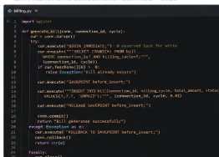
Fig. 1 — schema.sql: table definitions, constraints and indexes (Appendix A)

2. Transaction & Concurrency Control — Code
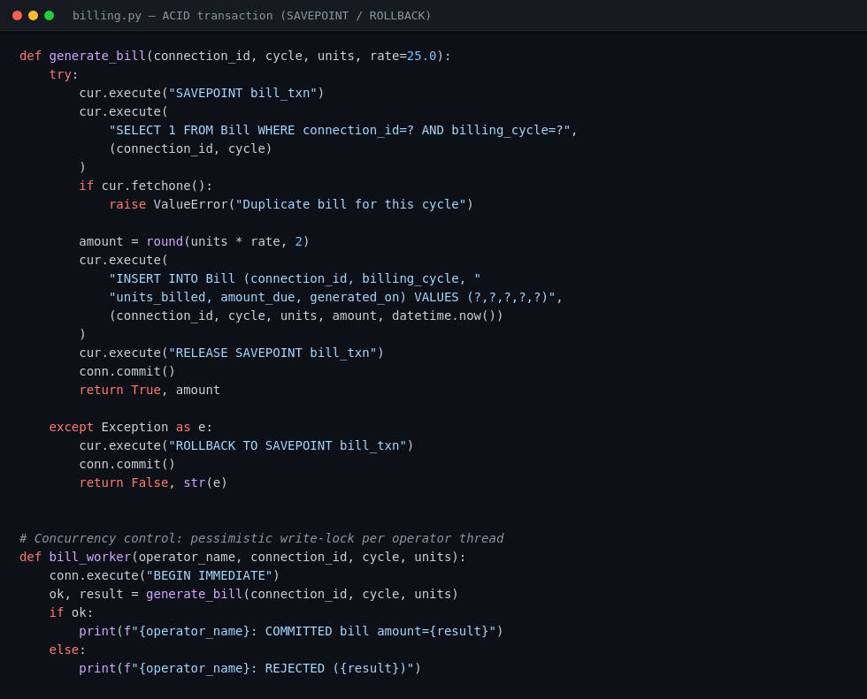
Fig. 2 — billing.py: SAVEPOINT-bounded ACID transaction and BEGIN IMMEDIATE concurrency control

3. Execution Evidence
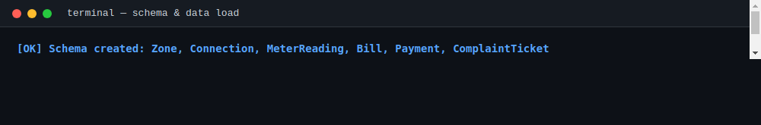
Fig. 3 — Schema creation and sample-data load (500 connections, 360,000 meter readings)
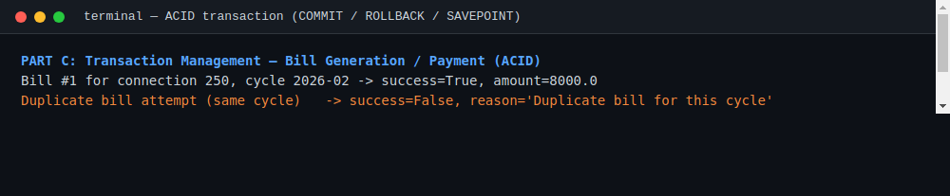
Fig. 4 — Bill generation, duplicate rejection and rollback (ACID transaction test)
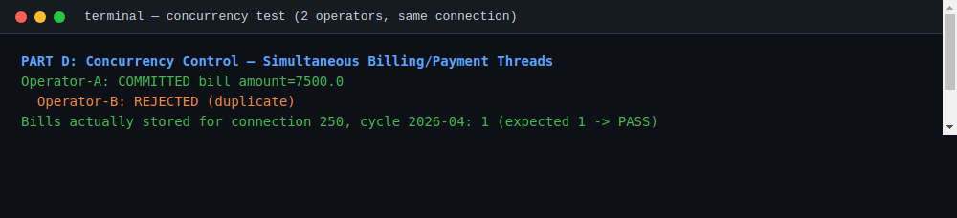
Fig. 5 — Two operators racing to bill the same connection/cycle (concurrency test)

4. Website — JalNiyantran Zonal Operator Console
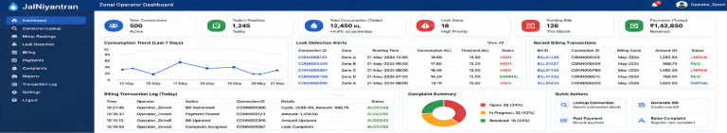
Fig. 6 — Live operator dashboard: connection lookup, leak detection, billing transaction log (https://zonal-water-operator-3zvb.bolt.host)

